
Callington Community College
Uniform Policy 2026-27

At Callington Community College, we believe our uniform fosters a sense of belonging, pride and identity; moreover, it signals a readiness to be part of our learning community. It sets high standards and makes an important contribution to a positive and purposeful working environment. We are very proud of our community at Callington Community College and want all our students to show that they are too, by wearing our uniform with pride. We therefore have a smart College uniform which is compulsory to wear at all times on the journey to and from the College and during the College day.

Schools are permitted to have up to 4 compulsory branded items including a tie.
Our compulsory branded items are:
Uniform item | Details | Available from
College Blazer - Royal Blue embroidered with the College logo  or  College jumper - Royal Blue  v-neck style | Students must wear one of the College Jumper or Blazer.  Must be worn at all times unless permission is given for it to be removed. | Colin’s of Callington
College Tie – Navy and Gold, | Clip on tie | Colin’s of Callington
College Tartan Skirt | Students can also wear generic grey, formal trousers instead of the skirt | Colin’s of Callington
PE Top – Navy and gold | Short sleeved and including the College logo | Colin’s of Callington

Compulsory generic (unbranded) items:
Uniform item | Details | Available from
Plain white collared shirt | Long-sleeve or Short-sleeve | Available from a range of retailers
Grey formal trousers | Tailored style trousers | Available from a range of retailers
Black, grey or white ankle socks or black tights | Socks must not be worn over tights | Available from a range of retailers
Black polishable school shoes | Must be all leather or leather-look (not fabric). | Available from a range of retailers. (Please see additional guidance below)

Plain white collared shirt – Shirts must be worn tucked in with all buttons fastened to the neck. They must be a formal/smart white shirt. Polo shirts or other styles are not acceptable.

College tie – The tie must be clipped onto a fastened top button.

Trousers – Trousers must be grey, traditional, formal style tailored school trousers as available from Colin’s of Callington. Trousers purchased elsewhere must be of the same style and meet College expectations. (Other styles such as jeans, leggings, cords, chinos or cotton jersey style trousers are not permitted, even when marketed as a “school trouser”.) Please ensure that trousers conform to this before purchasing.

Shorts - Students may wear smart grey tailored shorts of the same material as trousers in warmer weather if desired. These must be of a length to fall to the knee or just above.

Skirt – The College tartan skirt is the only style of skirt that may be worn. The three or four buttons (depending in length purchased) on the front of the skirt must be clearly visible and skirts must be knee length. The skirt is available in two lengths. Please ensure that you purchase the length that meets these expectations. Skirts must not be rolled up, cut or taken up to adjust their length.

Jumper – The College jumper is an optional item that may be worn instead of the blazer. No other jumpers, cardigans or hoodies etc. are permitted with the exception of the College branded reward hoodies for students in Year 10/11.

Socks – Plain black, grey or white ankle socks OR plain black tights must be worn (no trainer socks or leggings). It is not permitted to wear socks over tights.

Shoes – All students must wear plain all black flat shoes with black laces (if applicable) and have no obvious logos. They must be water-proof (leather-look/polishable) and of a style that is not likely to endanger the wearer whilst in College. Boots, suede or canvas shoes, hi-top trainers, open-toed shoes, sling backs, sandals or flip flops are not permitted. A shoe marketed as a school shoe may not be acceptable at Callington Community College. Please see the guide below for details.
SHOE GUIDE
Examples of ACCEPTABLE shoes (not an exhaustive list)
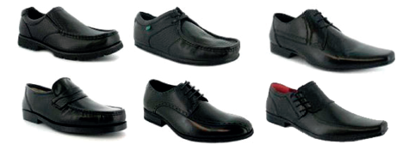
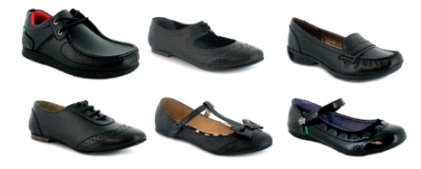
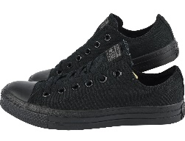
Examples of UNACCEPTABLE shoes (not an exhaustive list)
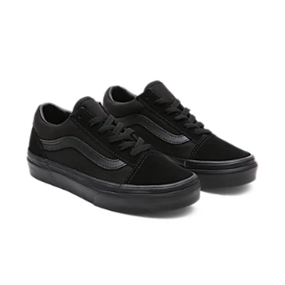
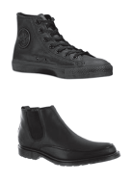

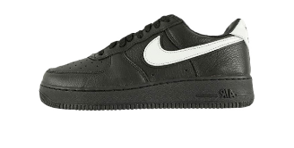

No high tops No vans/converse styles No ankle boots/boots No white/coloured branding

Coats – Weatherproof outdoor coats must be acceptable for College use and should only be worn outside or between lessons. Denim, leather, imitation leather jackets, tracksuit tops and hoodies are not acceptable. Coats should not display any inappropriate logos. In cold or wet weather appropriate hats and scarves may be worn to and from College.

Hair – If longer than collar length, hair must be tied back in situations where it could cause a danger to the individual or others, such as in PE and other practical lessons. Extreme fashion hairstyles (e.g. very short crew cut, decorative shaved elements or motifs) and extreme hair colours are not allowed (e.g. hair must be of a natural colour).

Jewellery - Students are permitted to wear a maximum of one small discreet stud earring in each ear and one finger ring of plain design, all of which must be removed for practical and PE lessons. One small colourless plastic retainer is permitted in nose piercings. No other items of jewellery, including jewellery in nose piercings or other facial piercings (including tongue piercings) are permitted under any circumstances. We accept no liability for jewellery brought into College.

Make up - No make-up is to be worn by students in Years 7 and 8. Any make-up worn by students in Years 9 to 11 should be natural and discreet. Colourless nail varnish only may be worn. False nails or nail extensions of any description represent a health and safety risk and may not be worn. Students will be required to remove inappropriate make-up, nail varnish or false nails. False eyelashes should not be worn.

Bags – A school bag, ideally waterproof and capable of comfortably holding 5 x A4 books alongside a pencil case, drinks bottle etc. Ideally of rucksack style but smart handbags are acceptable. Bags should have no inappropriate logos or slogans. Tote bags and other types of bag are not acceptable.

Lost property - The College cannot accept any responsibility for loss of property. Please ensure that all items of clothing are clearly marked with your child’s name.
College PE kit for Years 7 – 11 inclusive
Navy & Gold short sleeve t-shirt embroidered with College logo | Compulsory | Available from Colin’s of Callington only
Navy sweatshirt embroidered with College logo | Optional | Available from Kitworld Plymouth only
Navy and gold ¼ zip training top embroidered with College logo | Optional | Available from Colin’s of Callington only
Navy ½ zip shower-proof jacket embroidered with College logo | Optional | Available from Kitworld Plymouth only
Navy/black under-layer (top) | Optional | Widely available from sports retailers
Football Socks (navy, navy and white or navy, white and gold) | Compulsory | Widely available from sports retailers
College football socks –  Navy, White and Gold | Optional alternative to the generic football socks | Available from Colin’s of Callington only
Plain navy or plain black shorts | Compulsory to wear one of these 3 items | Widely available from sports retailers
Plain navy or plain black training pants/leggings | Compulsory to wear one of these 3 items | Widely available from sports retailers
Navy Skort | Compulsory to wear one of these 3 items | Widely available from sports retailers
Sports footwear | Compulsory | Widely available from retailers. (See additional guidance below)
Shin pads for Football & Hockey | Compulsory safety equipment for all Years | Widely available
Gumshields for Rugby & Hockey | Strongly recommended for all Years | Widely available

Navy & gold short sleeve t-shirt – The only short sleeve PE top permitted. This t-shirt should be worn for all PE lessons.

Navy or black shorts – Plain navy or plain black shorts should be worn for all activities unless navy/black training pants/leggings are being worn. Any Nike Pro shorts must be navy/black and of 13cm or 18cm length, NOT the 8cm length.

Navy and gold College ¼ zip training top – This top can be worn for outside lessons as an additional warm layer.

Navy shower-proof ½ zip jacket – this top can be worn for outside lessons as an additional layer.

Navy/black under-layer/base-layer – this can be worn under the College t-shirt to cover forearms.

Navy College sweatshirt – this top can be worn for outside lessons and as an additional warm layer.

Navy football socks – These should be worn for football and rugby activities and should be pulled up. Plain white sports socks are acceptable for indoor activities. Black school socks should not be worn.

Plain navy or black training pants/leggings – These items are available as an alternative to shorts.

Navy Skort – This can be worn as an alternative to shorts.

Sports Footwear – Students should wear suitable footwear for sport. Converse/Vans or similar fashion trainers are not appropriate. Students will need astro footwear in order to use the 3G pitch, these can also be used in our other facilities and therefore are the footwear of choice. Rugby boots will be required by students taking part in rugby on the field. Students will be notified if these are required.
Safety Equipment – Shin pads/Gumshields are essential for the safety of all students whilst undertaking certain practical activities and are based on the sport’s governing bodies’ recommendations. These are widely available from most sports shops.
PE Expectations

- The only jumpers/training tops permitted to be worn over the t-shirt must have a College logo. Underlayers/base-layers can be worn for outside lessons, and sports-appropriate coats/jackets are permitted in cold/wet weather.

- If a student is unable to physically take part in the lesson, they will need a date note from a parent/carer, explaining the reasons for this. Students should still bring their kit in order to assume a different role in the lesson.

- If students forget their PE kit, they are expected to wear spare, clean kit which is provided by the College.

- Items of kit must be clearly marked with the owner’s name and students must take responsibility for ensuring that they leave the changing rooms with all of their belongings.
- Students with long hair are expected to bring a hair tie to every lesson and no jewellery is to be worn for any PE activity for safety reasons.

Compulsory branded items: Optional branded items:
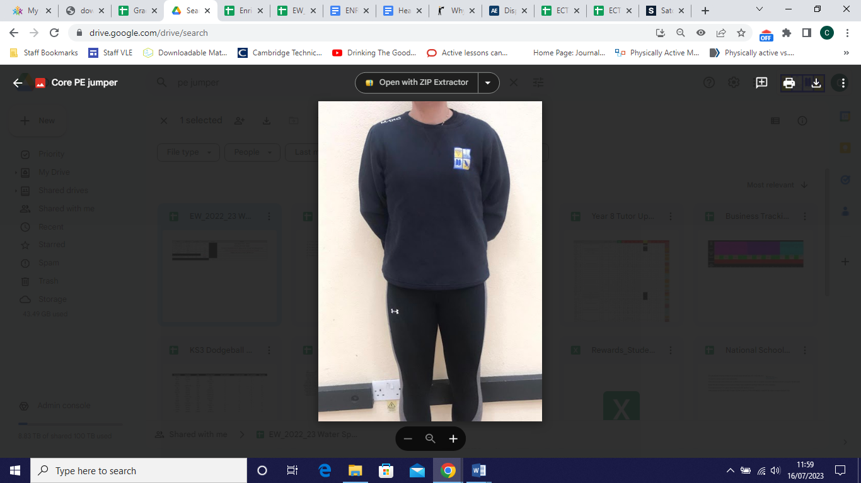
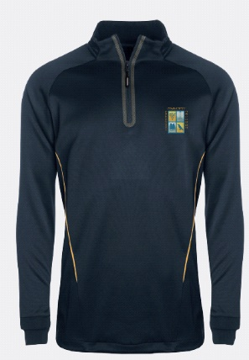
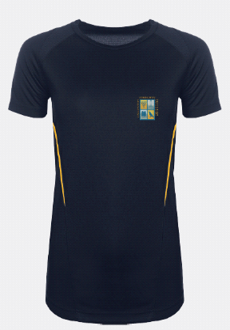
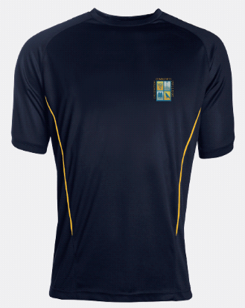

OR

Boys PE Top Girls PE Top ¼ Zip PE Top Navy Sweatshirt
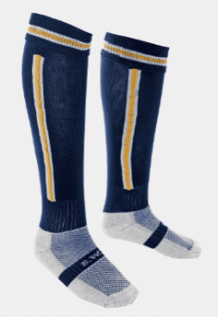
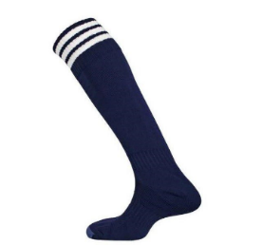
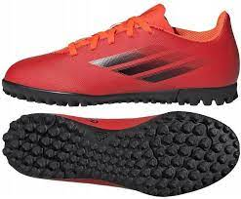
Compulsory generic (unbranded) items:
Navy and white
football socks
(Instead of the
College football socks)
College football socks
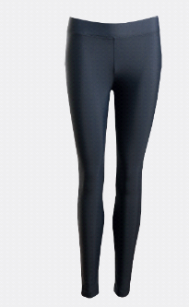
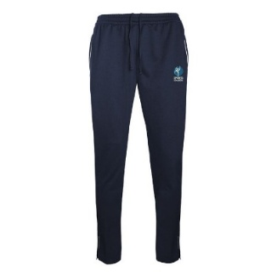
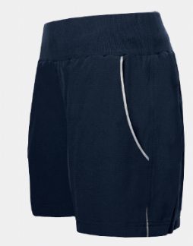
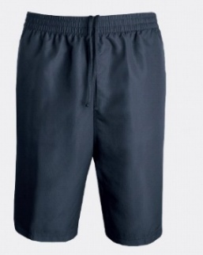

Navy or black Navy Skort Navy training pants Navy/Black
shorts Sports leggings


Second Hand Uniform Shop - UNIFORMD
We have a second hand uniform website.
With increasing financial pressures for all families, I am incredibly grateful that we are able to offer this resource and hugely thankful to the parent forum members and staff teams who have helped sort and organise uniform items ready for the platform, coupled with the hours of setting the platform up.
You will find our second uniform shop here; Uniformd
It has a host of items, all arranged by size, and the number of items available is clearly indicated, along with price.

